**Assignment 03 – WordPress CMS Website (Basic Pages)**

**Instructions for completing template:**Replace **[bracketed red text]** with the requested information or screen capture.  
Replace **bracketed red text with black text** and then remove the brackets.  
Do not include full screen shot images, or full screen shots that are reduced in size. Use a snippet tool to capture parts of the screen and insert those images into the template.  
Do not remove tags from this template. Please answer all questions.  
**Please do not alter the formatting or delete parts of this template.**  
Assignment questions are not as detailed as activity questions.   
The assignment is where you demonstrate understanding of the material.

**Part A - Student Information**

1. **Student Name: [SYED AFTAABUDDIN] [A01]**
2. **Student Email: [syedaftab299@gmail.com] [A02]**
3. **Student Phone #: [773-796-0029] [A03] *Optional**

**Go back to the instructions and begin work on part B.**

**Part B - Create 1 Shared Web Host WordPress CMS Website**

(1) Shared Web Host WordPress CMS Site Information:

Shared Web Host Name: **[Name cheap**] [B01]  
Shared Web Host URL: [**www.namecheap.com**] [B02]  
Shared Web Host Site Admin Username: [**saftaabu**] [B03]   
Shared Web Host Site Admin Password: [**50297006@Sps**[B04]

Website Admin Username: [**saftaabu**] [B05]  
Website Admin Password: [**u1Ra^w@]8%n0R** [B06]  
Database Name: [**wp997**] [B07]  
Table Prefix: [**wp5f_**] [B08]  
WordPress CMS Website URL: [**http://syedaftab.tech/mod3assign3/**] [B09]

-OR-

(2) Pantheon – WordPress CMS Site Information:

**Assignment Website Site Name:** **[Site Name here] [B01]**

**WEBSITE Admin Username:** **[Admin Username here] [B02]**

**WEBSITE Admin Password:** **[Admin Password here] [B03]**

**Pantheon Frontend Website URL:** **[Frontend website URL here] [B04]**

**Note: Please do not provide the Backend URL for B04 above.**

**Go back to the instructions and begin work on part C.  
  
Part C - Extend the WP Site with Theme and Menu**

1. SCREEN CAPTURE of the backend WordPress Themes page **[Dashboard > Themes]   
   [C01]  
   [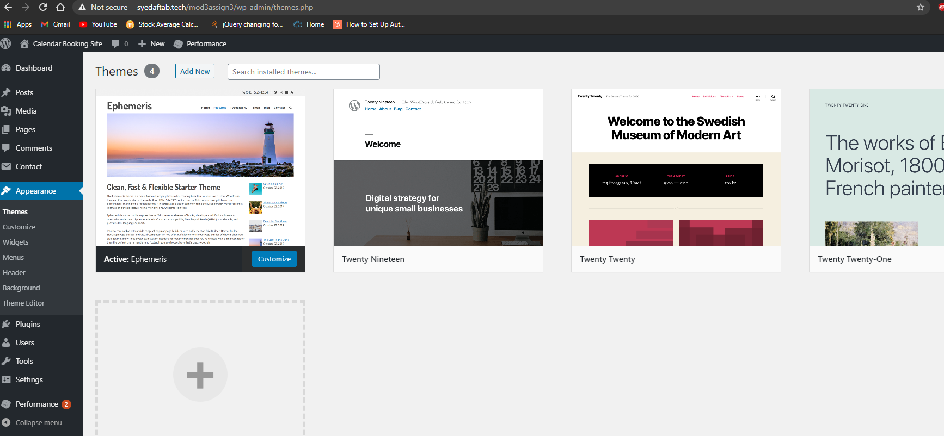]**
2. SCREEN CAPTURE of the backend WordPress **Media** Page **[Dashboard > Media]** showing the site images   
   **[C02]**  
    **[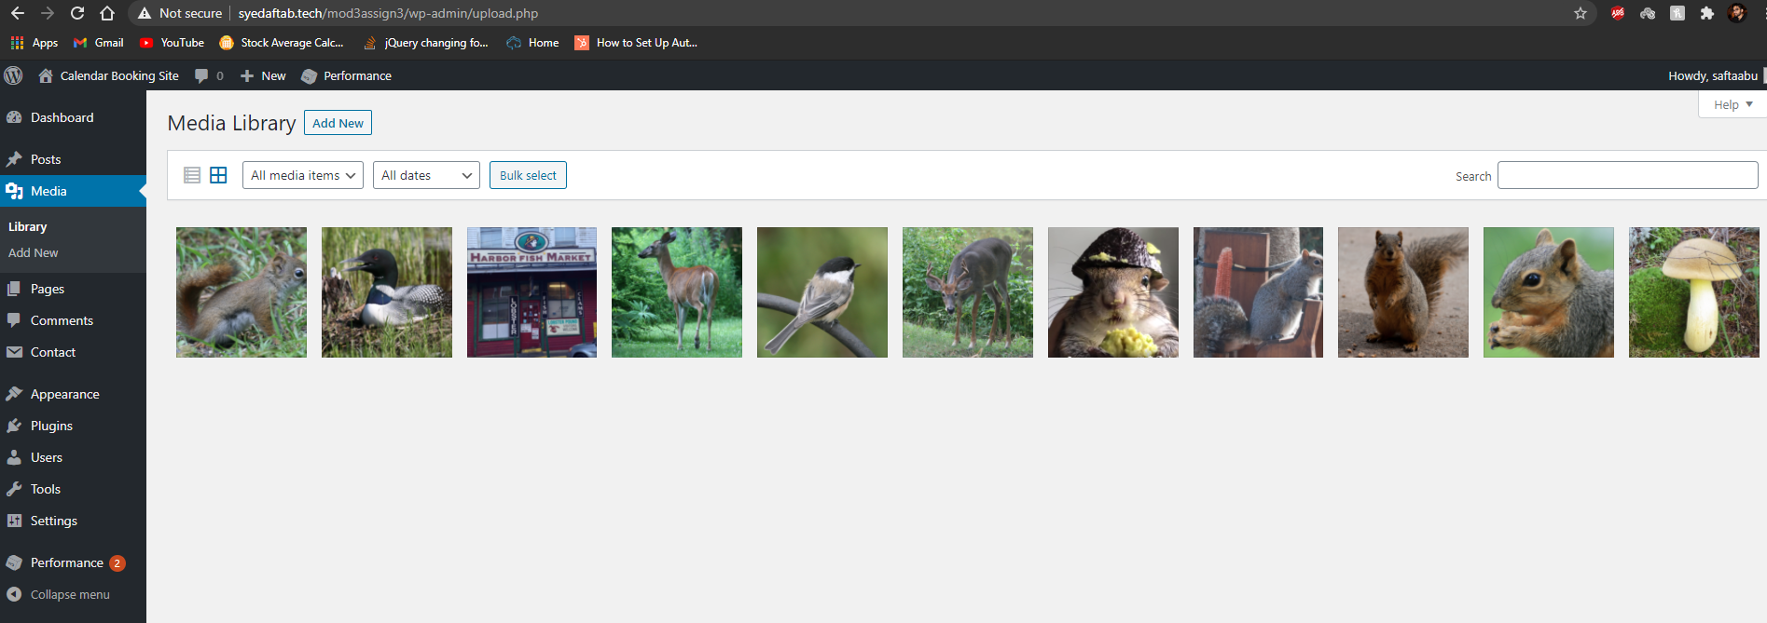]**
3. SCREEN CAPTURE of the backend WordPress **Posts** Page **[Dashboard > Posts]** showing the 2 Posts, categories and Tags  
   **[C03]**  
    **[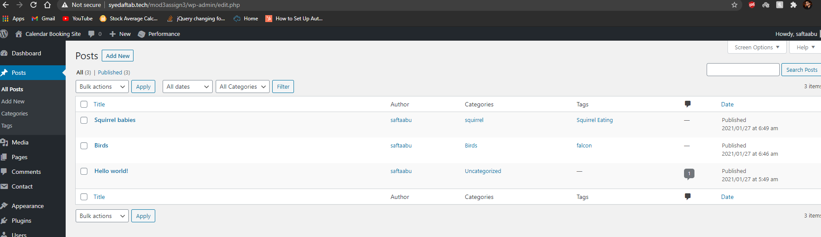]**
4. SCREEN CAPTURE of the backend WordPress **Pages** Page **[Dashboard > Pages]** showing the Pages  
   **[C04]**  
    **[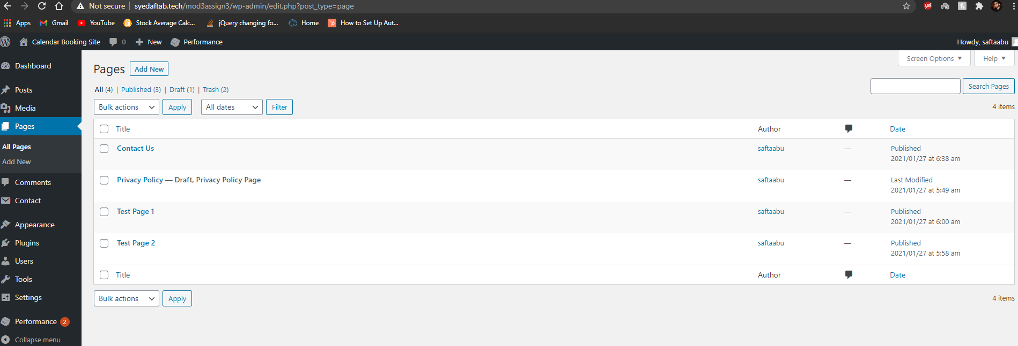]**
5. SCREEN CAPTURE of the backend WordPress **Plugins** Page **[Dashboard > Plugins ]** showing the Plugins you installed   
   **[C05]**  
    **[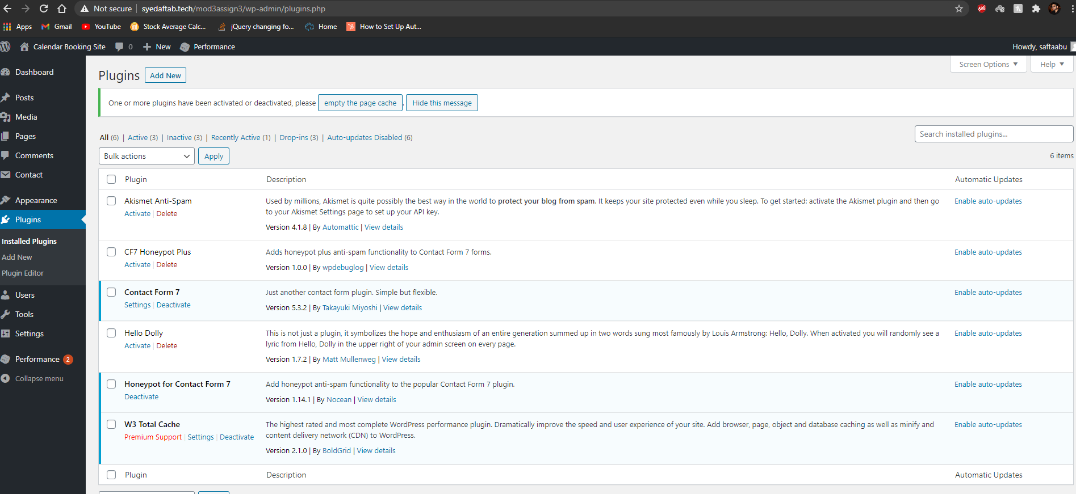]**
6. SCREEN CAPTURE of the backend WordPress **Contact Us Form**    
   **[Dashboard > Contact]** then select Edit on the Contact Us Form  
   This will display the Form fields including the 2 honeypot fields  
   **[C06]**  
    **[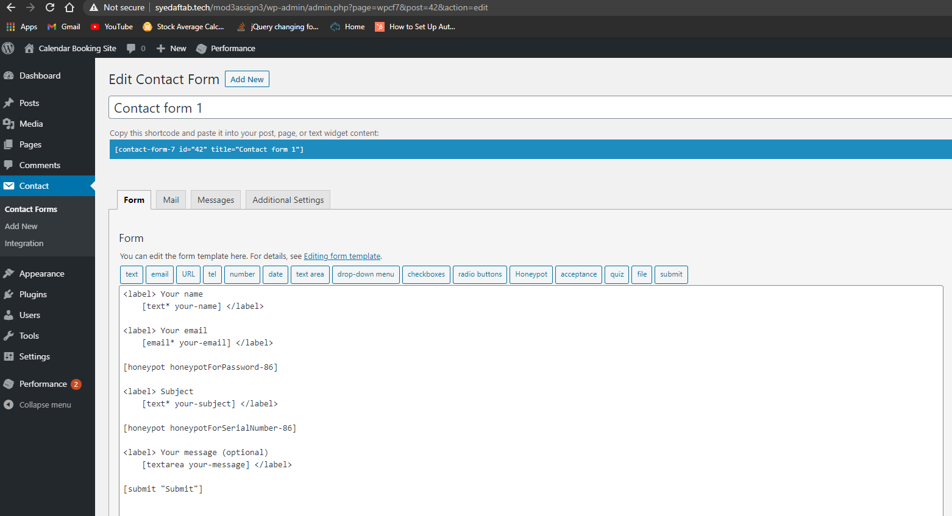]**
7. SCREEN CAPTURE(s) of the client facing FRONT-END showing Page content   
   **[C07]**  
    **[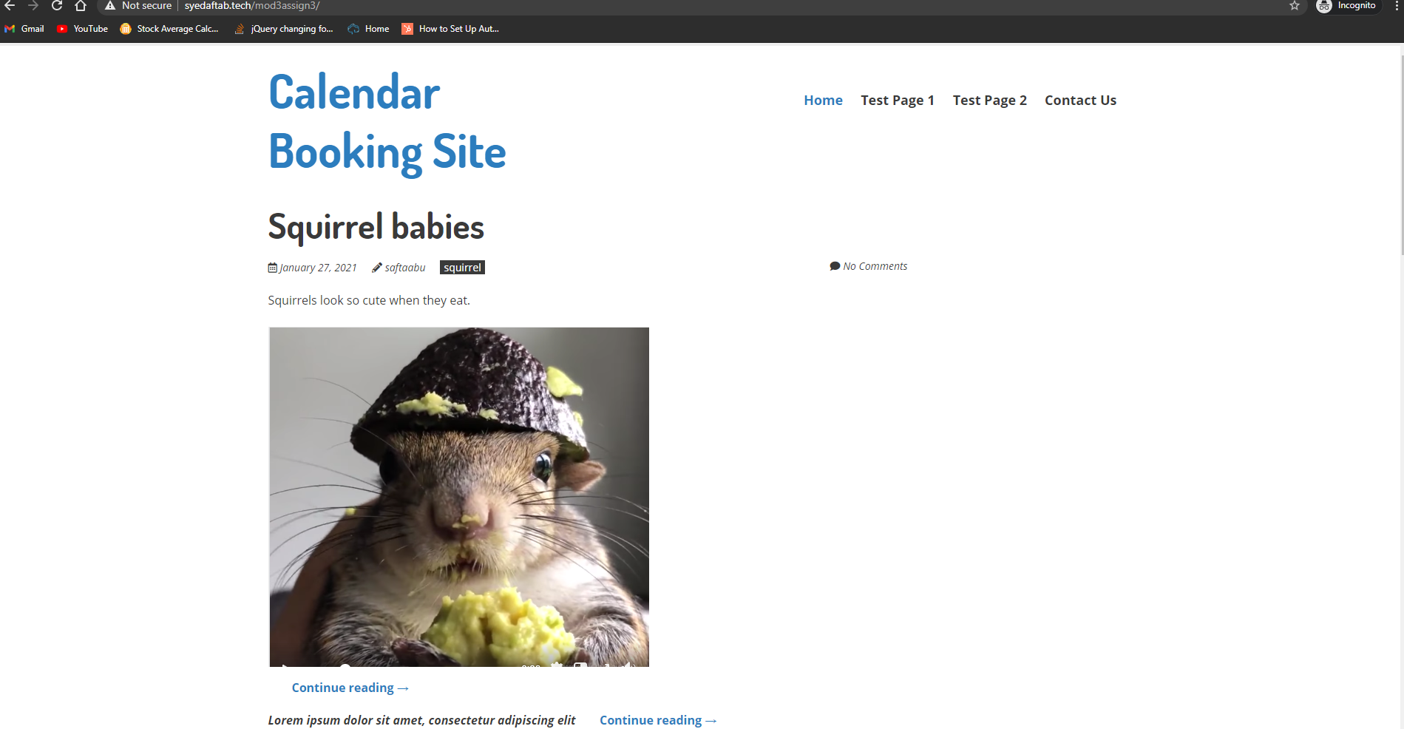]**
8. SCREEN CAPTURE(s) of the client facing FRONT-END showing Post content   
   **[C08]**  
    **[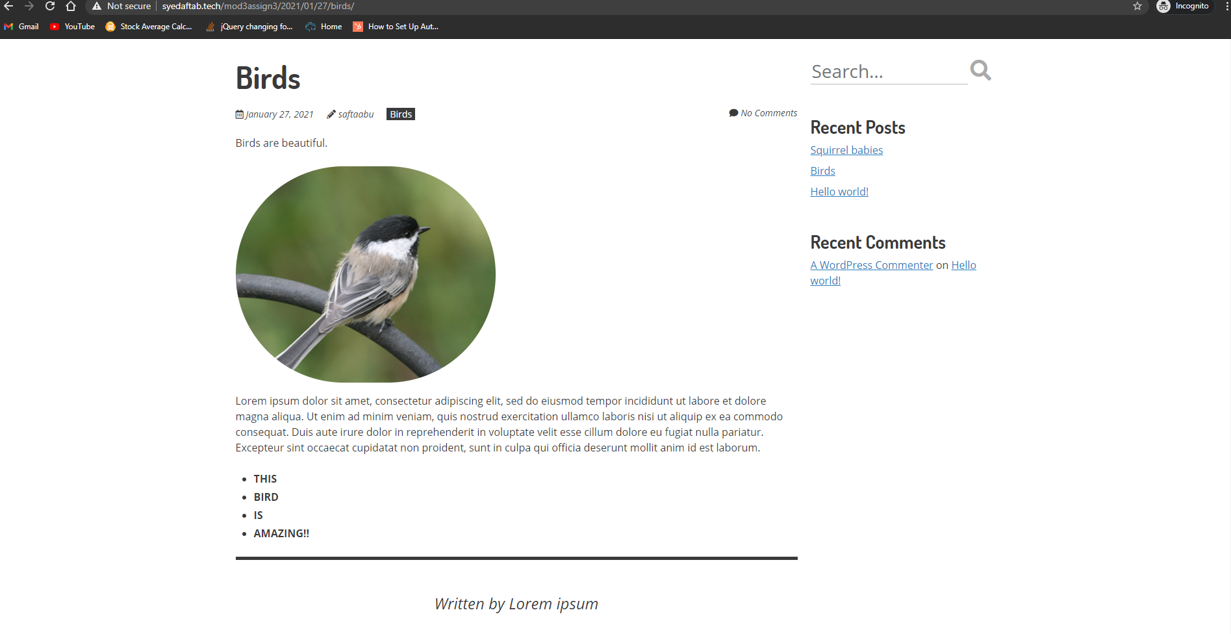]**
9. SCREEN CAPTURE of the client facing FRONT-END showing your Contact Us form   
   **[C09]**  
    **[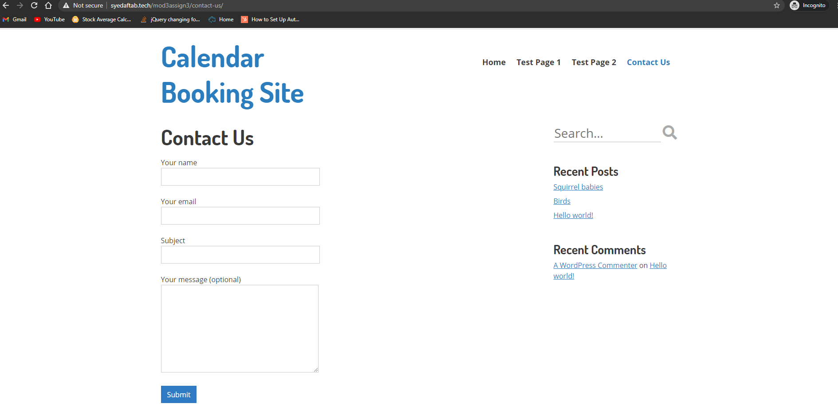]**
10. List the names of the 2 Honey Post Fields you added to the Contact Us form   
    **[C10]**  
     **[[honeypot honeypotForPassword-86]**

**[honeypot honeypotForSerialNumber-86]]**

**Go back to the instructions and begin work on part D.**

**Part D -** Shared Web Host – Demonstrate CMS Best Practices

1. List the plugins you selected for feature analysis and review**[D01]**  
   **[1. Amelia – Events & Appointments Booking Calendar  
    2. Appointment Hour Booking – WordPress Booking Plugin  
    3. WordPress Online Booking and Scheduling Plugin – Bookly]**
2. Take a screen capture of your feature analysis report and paste it here**[D02]**  
   **[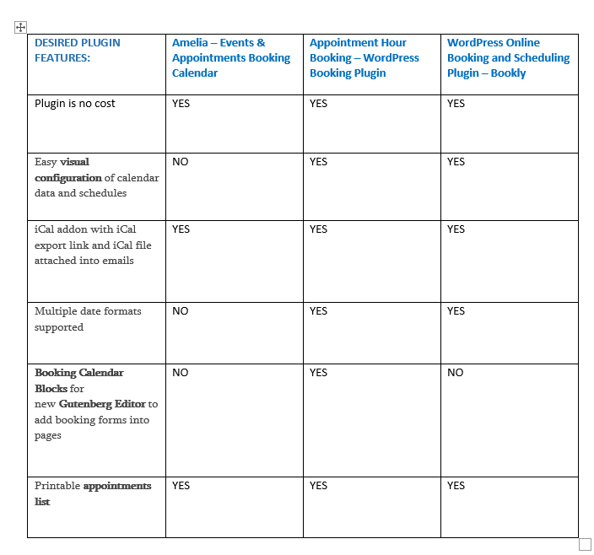Looking at the report, the recommended plugin to install I chose is Appointment Hour Booking – WordPress Booking Plugin as it checks all the requirements for the desired plugin features.]**
3. Record the name of the plugin you selected based best practices**[D03]**  
   **[Appointment Hour Booking – WordPress Booking Plugin]**
4. Write a few sentences that describe the 4 best practices you used to select the plugin**[D04]**  
   **[ - The plugin is compatible with the WordPress site version.**

* **The plugin is actively maintained.**
* **The plugin is actively used by large numbers of sites**
* **The plugin has good reviews with large numbers of installations.**

**]**

1. Backend SCREEN CAPTURE of the **Plugins** Page **[Dashboard > Plugins]** showing your Plugin you selected **[D05]  
   [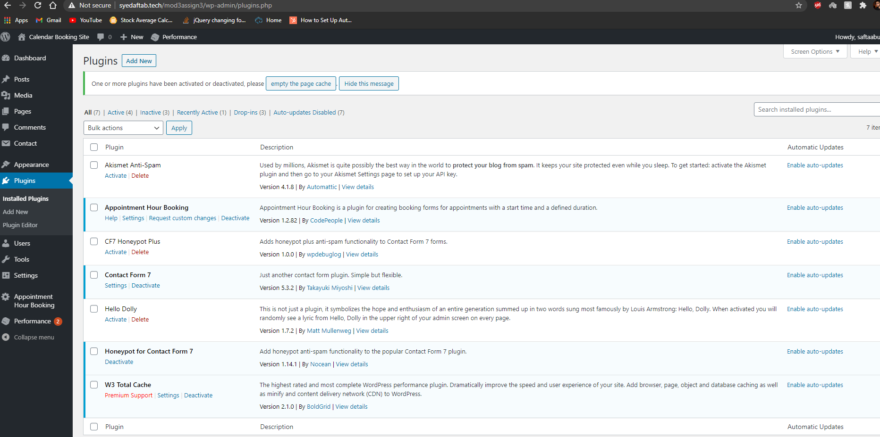]**
2. Front-end SCREEN CAPTURES of the implemented **Plugins** Pages**[D06]**   
   **[1. 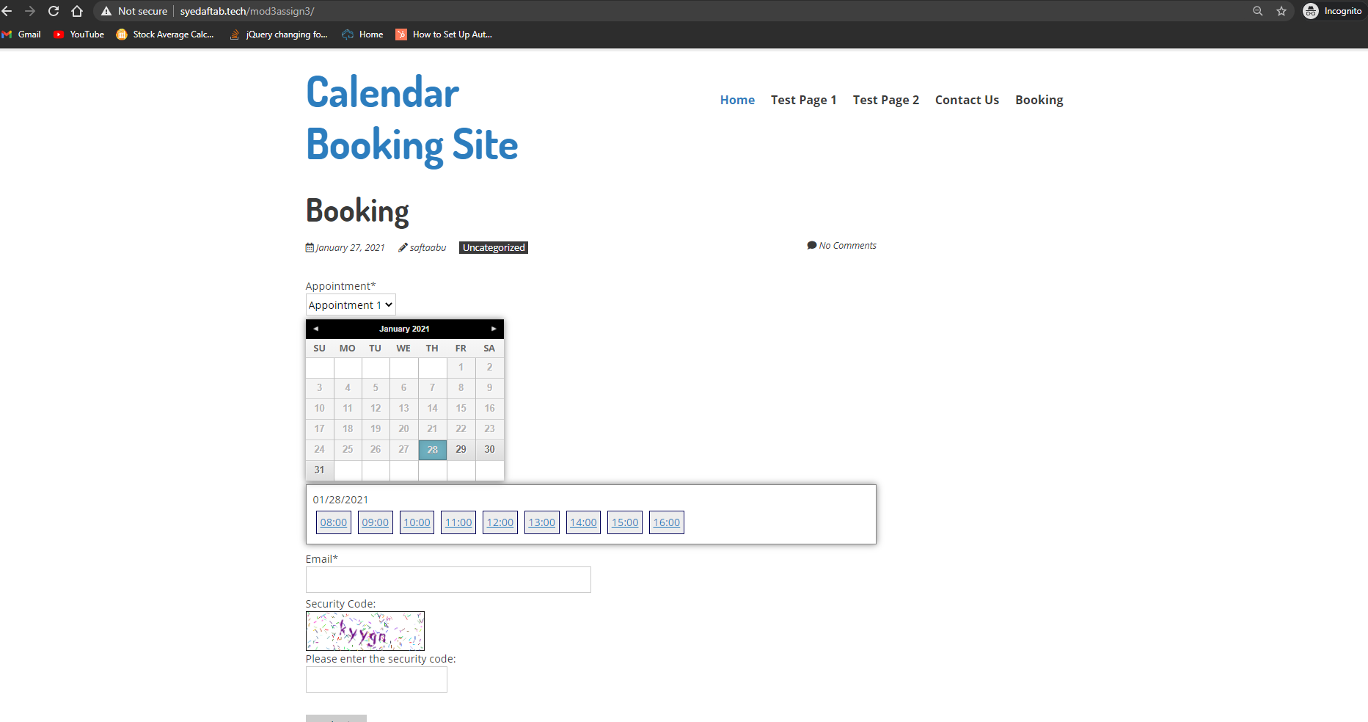2. 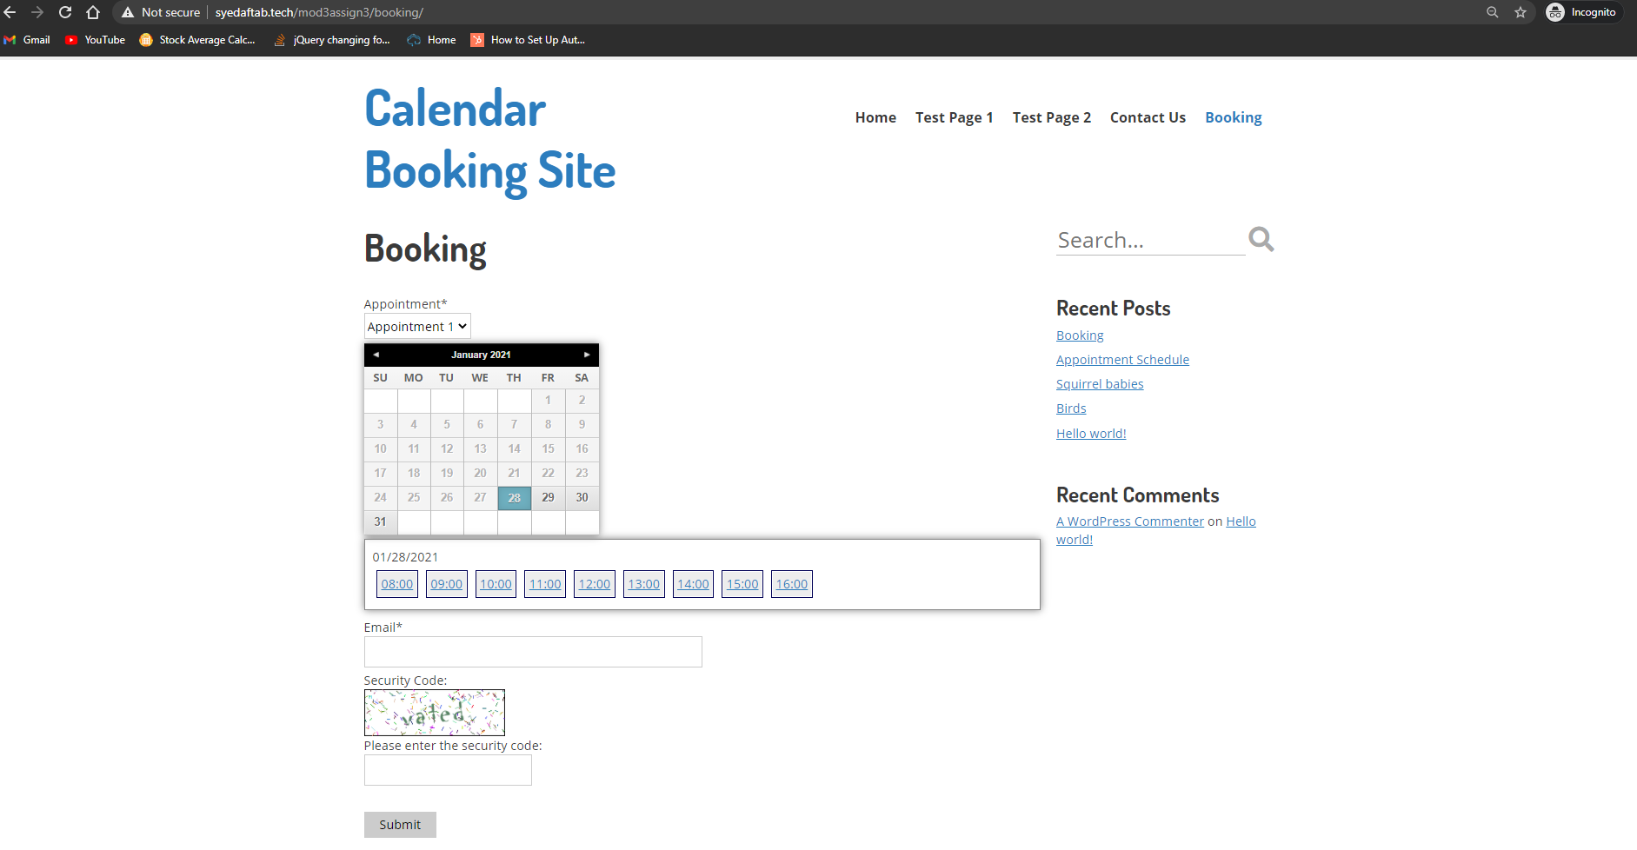]**

**Go back to the instructions and begin work on part E.**

**Part E - Testing PHP Programs using PHP Emulation Websites:**

* Online PHP test sites:
  + <http://phptester.net>
  + <http://www.writephponline.com/>
  + <http://sandbox.onlinephpfunctions.com/>
  + <https://wtools.io/php-sandbox>
* How you test your script depends on which test site you use.
* **Each PHP emulation test site works slightly different**.
* Please read the site instructions before testing your PHP code.

For more help on debugging and troubleshooting PHP errors, please refer to the Module 03 Presentation:  
  
M03 -09- PHP Troubleshooting Coding Errors

1. Demonstrate that you can create a PHP index array of 5 items and iterate through it using a   
   for statement (not a foreach). Write and test your PHP code using a web PHP emulator (tester) and take a screen capture of the working code and output window.   
   Please write your own PHP code.  
   Do not copy and paste provided PHP example code.

|  |
| --- |
| ANSWER: [E01] |
|  |

1. Demonstrate that you can create a PHP index array of 5 items and iterate through it using a foreach statement. Write and test your PHP code using a web PHP emulator (tester) and take a screen capture of the working code and output window.   
   Please write your own PHP code.   
   Do not copy and paste provided PHP example code.

|  |
| --- |
| ANSWER: [E02] |
|  |

1. Demonstrate that you can create a PHP associative array of 7 items and iterate through it using a foreach statement. Write and test your PHP code using a web PHP emulator (tester) and take a screen capture of the working code and output window.   
   Please write your own PHP code.   
   Do not copy and paste provided PHP example code.

|  |
| --- |
| ANSWER: [E03] |
|  |

1. Demonstrate that you can create a PHP program that uses control statements.  
    Write and test your PHP code that contains an if and an if else control statements and use a web PHP emulator (tester) and test, debug, fix and eventually take a screen capture of the working code and output window.

|  |
| --- |
| ANSWER: [E04] |
|  |

1. Demonstrate that you can create a PHP program that uses comparison statements.  
    Write and test your PHP code that contains an “==”, “===”, “<” , “>”, and the spaceship “<=>” operator. Use a web PHP emulator (tester) and test, debug, fix and eventually take a screen capture of the working code and output window.

|  |
| --- |
| ANSWER: [E05] |
|  |

**Go back to the instructions and begin work on part F.**

**Part F – Module CMS Questions:**

1. Write a few sentences about the WordPress Gutenberg editor, what it is and what are the benefits to using it over the Classic editor? This question may involve reviewing the assigned reading material. [F01]

|  |
| --- |
| Gutenberg editor is a new WordPress editor. The benefits of using Gutenberg is you can manage your content easily as you don’t have to have much knowledge in coding. Gutenberg also shows you how your front-end webpage is going to look like while you edit your content. For each paragraph/text, you can edit in blocks as it will be very easy to format your content. |

2. List and describe the two content types that come installed with WordPress. [F02]

|  |
| --- |
| **Pages** – Pages is a default content type in WordPress. Each page has its own content.  **Posts** – Posts are like blogs. It provides you with the newest content that has been posted on the website. |

3. List and describe 3 similarities and differences between content types Pages and Posts. [F03]

|  |
| --- |
| Similarities –   1. You can create unlimited posts and pages. 2. You can edit posts just like pages. 3. You can add images in both posts and pages.   Differences –   1. Posts are timely which means it has data/time published and Pages doesn’t have a publish date/time as they are timeless. 2. Posts have categories and tags to organize and pages don’t need tags or categories as they can be organized as child and parent pages. 3. Posts shows you in order as it displays the latest post posted and the old post is beneath it. Pages are not like that as they are hierarchical. |

4. Write a few sentences about WordPress Categories and Tags such as what content type they are applied to, how are they implemented, and their purpose on WordPress content. [F04]

|  |
| --- |
| Categories and Tags helps you organize your posts. For example, if you are creating a post for birds and fox, you use category. For tags, if you have different types of birds, you use tags to identify different birds. Same goes with creating a post with fox. Categories are a method of grouping content and post goes in depth for small details inside the category to organize them. |

5. List and describe 4 basic best practices you should follow when selecting a WordPress plugin, after determining that the plugin has the required features. [F05]

|  |
| --- |
| - **Compatibility** - Check if the plugin is compatible with your WordPress site. If not, then the plugin will give you problems as it may not work on your WordPress site.  - **Updated** - Check if its actively maintained.  - **Good reviews** - Check if it has large number of reviews.  - **# of installations by others** - Check if the plugin has large number of installations. If the installations are less then that just means not a lot of people prefers the plugin. |

**Go back to the instructions and begin work on part G.**

**Part G – Assignment Wrap up:**

1. **Did you have any problem or issues completing this assignment?  
   This is not an optional question.  
   [NO] [G01]  
     
   If you answered yes to this question, please elaborate and be specific.  
   If you had trouble with a specific question, please identify it by number and explain what you did not understand or had problems with.  
   I can only improve this assignment with your help.**
2. **[**List problems here**]   
   [G02]   
   *Only if you answered Yes to [G01] above or if you left one or more parts empty in the template.**

Submit this completed template to the correct D2L assignment dropbox.If you prefer not to navigate by hand to the D2L dropbox, take advantage of the dropbox link in the D2L this module’s section. This link will take you to the correct assignment dropbox location.